Comparison of the US and Russia’s Cultural Dimensions
Student Name
Institution Affiliation

Comparison of the US and Russia’s Cultural Dimensions
Part One
Organizations worldwide are growing increasingly multicultural as a result of aspects such as globalization and technological advancements. Based on the facts shared in the case example, the company purposes to set up operations in Russia. While it has opted to hire Russian employees, the company purposes to employ US human resources practices across the offices in the region. Studies have shown that cultural differences can be significant impediments to the success of multinational corporations. In this regard, Hofstede’s six dimensions of culture can be applied to ensure the success of the company in Russia. The summary of the comparison of the dimensions of culture between Russia and the US is as shown in the figure below.
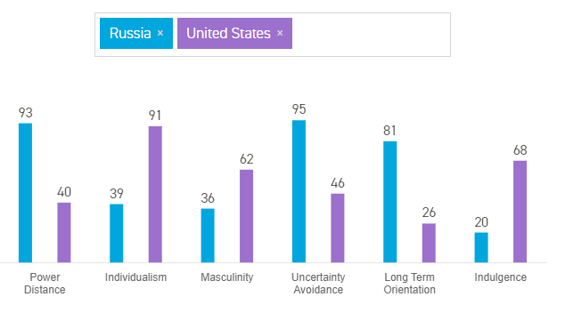
Power Distance Index (PDI): It relates to the degree of inequality that not only exists but is also accepted by persons with and without power (Demmler et al., 2018). From the figure above, the US has a lower PDI which means that the society challenges inequality and thrives on the sharing of power.
Individualism vs. Collectivism (IDV): It refers to the strength of ties that persons in the community have with each other (Demmler et al., 2018). According to the results above, the US has a high IDV. This indicates weak interpersonal connections among people outside the core family.
Masculinity vs. Feminism: It entails the distribution of roles among men and women in society (Demmler et al., 2018). It is evident from the figure above that US is a highly masculine society characterized by strong egos and where money and achievement are of utter importance.
Uncertainty Avoidance Index (UAI): It is the dimension that showcases how individuals cope with anxiety (Demmler et al., 2018). As per the results, Russia has quite a high UAI meaning that it is conservative, rigid and structured.
Long vs. Short-term Orientation: According to the results, Russia has a long-term orientation as such, the locals can be identified as modest and emphasize virtues and obligations.
Indulgence vs. Restraint (IVR): According to the figure above, Russia exhibited a low IVR score which shows the restrained culture of the locals. Russians are more controlled and possess rigid behaviors compared to Americans.
Part Two: Success of US HR Practices on Russian Employees
It is vital to critically examine whether some of the US HR practices will be beneficial to the Russian employees.
Extensive assessment to determine individual abilities: According to the results shown in the figure above, Russia has a low IDV. This means that Russians are more inclined towards group needs as opposed to individual needs. As such, unlike Americans, Russians don’t harbor the expectation of individual rewards for hard work. They tend to work for intrinsic rewards (Hofstede Insights, 2021). As such, the proposed US HR practice will not be successful among Russian employees.
Self-managing Work Teams: Considering Russia had a high PDI score, it is safe to say that it will be difficult to employ the US HR practice of self-managing teams. This is because Russian employees thrive best in centralized organizations with more complex hierarchies (Hofstede Insights, 2021). Russians understand their place in the “system” and are less inclined at working independently and without supervision as is the case in America.
Individually-based appraisal Systems: This HR practice is likely to fail among Russian employees because Russia is a collectivist society. Employees particularly those who associate themselves to a certain group or faction are loyal and work best in teams (Hofstede Insights, 2021). As such, an individually-based appraisal system will be shunned as it will be deemed to cause disunity in the organization by fostering unfair competition.
Employee Suggestion Systems: Russia has a low IVR score and which indicates that the locals exhibit a restrained culture and are highly pessimistic. Freedom of speech is not entirely important and employees are often reluctant to offer their recommendations and feedback. As such, an employee suggestion system is also likely to fail.

References
Demmler, M., Ortiz Ayala, R., & Urbiola Solís, A. (2018). Comparing Corporate Cultural Profiles Using the Cultural Dimensions of Hofstede. Journal Of Business And Management Sciences, 6(2), 28-35. https://doi.org/10.12691/jbms-6-2-1
Hofstede Insights. (2021). Country Comparison - Hofstede Insights. Hofstede Insights. Retrieved 13 April 2021, from https://www.hofstede-insights.com/country-comparison/russia,the-usa/.

